The Top Ten Top 10s

As the "old year" drew to a close and the new year approached, my inbox was deluged by dozens of sustainability "Top 10" lists. Some were of the year past and some were focused on the year ahead. But they were all “Top 10,” and we probably have David Letterman to thank.

Like most everyone, I like a good Top 10 list, so I read through these and selected my favorite ten – all from sustainability leaders that I greatly respect, especially Joel Makower, with whom I worked at GreenOrder, and Andrew Winston, with whom I now work at Winston Eco-Strategies.

In addition to Joel and Andrew, the other Top 10s come from the following sources: BusinessGreen, CarbonTrust, Ecova, Ethical Corporation, Greenbiz, The Guardian, Triple Pundit, and SustainAbility.

A quick data summary from these leaders’ Top 10 lists:

- The Obvious: there are 100 data points from ten Top 10 lists
- The Overlap: there are 67 data points that are shared among the leaders
- The Unique: there are 33 unique data points among the leaders, with Joel, BusinessGreen, and TriplePundit each having 5 unique points
- The Total: therefore, there are 46 unique points (out of a possible 100)
- The Most in Common: the most common point made was “Climate Change Action Gains Momentum” with 5 (Greenbiz, Sustainability, The Guardian, Andrew Winston, Joel Makower) of the 10 leaders sharing this point

To check my math, please see below a Venn diagram of the contents of these lists. For example, the contents in the middle appeared in 2+ of the lists, and the rest appeared only in the respective lists.

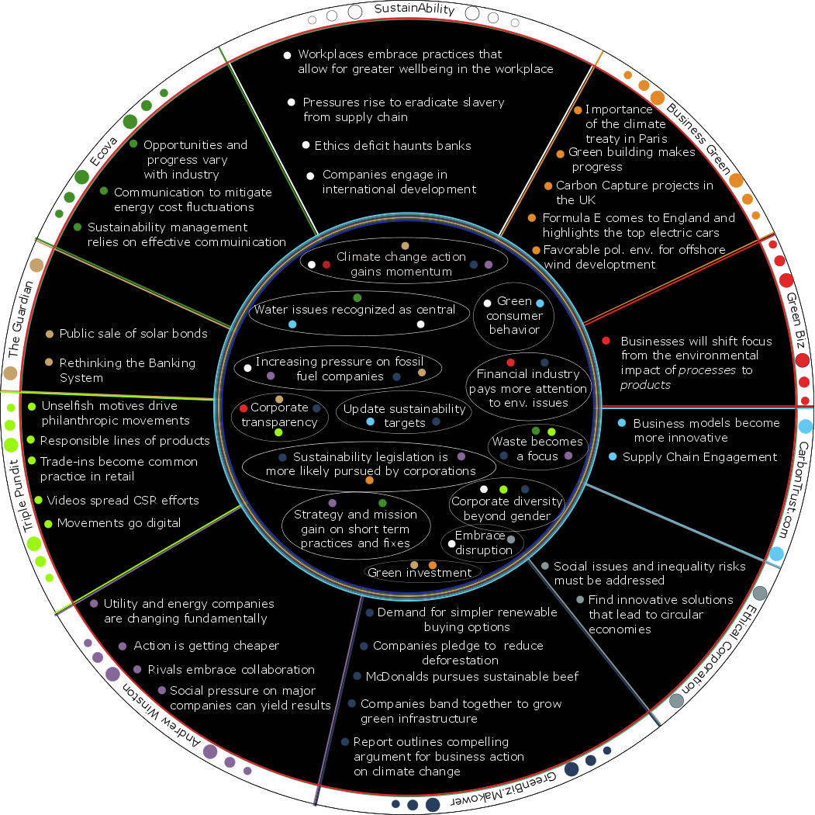

What to make of this? I'll keep it to three takeaways:

1.) The Environment Still Dominates – sustainability is often categorized into three ESG (Environment, Social, Governance) buckets. Historically this three-pronged stool has been more of a really thick trunk (Environment) with a couple of scrawny branches (Social, Governance). A quick ESG categorization of the 46 unique points yields:

* Environment: 22
* Social: 10
* Governance: 5
* Spans all three: 9

The environment still rules but the others are gaining.
2.) It’s All About Climate – as noted above, the most common point made was the momentum on climate action. This is heartening, as most everyone in the sustainability community understands that the other E, S, and G issues are all moot in world that is 10deg Fahrenheit warmer.

Somehow this point has not reached the general public, but we will keep trying.

3.) Unexpected Players and Moves – very few expected Walmart to emerge as a key sustainability player in 2006 with the launch of its Sustainability360 program. I was equally surprised and impressed with the moves made by CVS and McDonald’s in 2014. CVS removed tobacco products from its stores in a move to align its products with its brand image of “promoting health and reducing the burden of disease.” Not impressed? That move took $2B in annual revenue off the books. That is arguably the most bold and impressive sustainability move to date. Equal (or greater) in scope and plans, was McDonald’s announcement to begin purchasing sustainable beef in 2016 – the first step in a path to 100% sustainable beef worldwide. That’s not a game changer. That’s a system changer.

Year by year, more and more companies see the business value in sustainability. Sometimes, it begins as immediate cost savings. Sometimes, it is realizing revenue opportunities from customers who want sustainable products from sustainable operations. Sometimes it is looking ahead to reduce risk (such as future costs) or build brand value (such as future sales).

Once in, these companies then realize that not only is sustainable business a current driver of company value but also is quickly approaching “standard operating procedure.”

